PRESENTING YOUR PAPER
- Clearly state the purpose of your entry – what is the overriding goal of this submission?

- Get to the point! Be concise and explicit. Ensure that the submission is easy to read.

- It is not enough to make assertions, the jury want proof! Any claim must be supported by evidence and source data. For example:

  - Claim: Any figure/number used. For example: The sales figures went up by 120% See Figure 1.
  - Evidence: Use a chart, graph, diagram, etc. within the body of your submission. You must reference the name of the source. For example: Nielsen: Marketing Survey 2009. “Mobile Youth Around the World”
  - Source Data: The study or report which the claim has come from. For example: the “Mobile Youth around the World” survey must be sent as a supplement included in the appendix.

- Embed any supporting evidence such as charts, graphs, tables etc. within the main entry document, next to your claim. Charts, graphs, diagrams or tables will not be included in the word count.

- Include footnotes at the bottom of the page linking to the source data in the appendix.

- The source data must be submitted along with the entry in order for Spikes Asia team to check for consistency. This should be included as appendices. If you cannot include the source data please state the reason why.

EXAMPLE 1
Footnote directs reader to Source Data

Claim. Refers to the Evidence

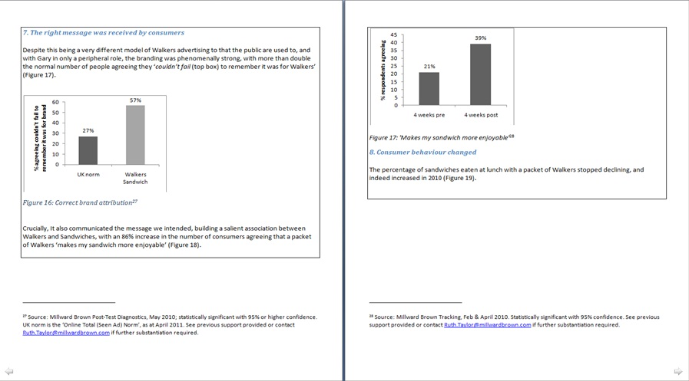
Evidence. Clearly labelled chart with heading. References the name of the source

EXAMPLE 2
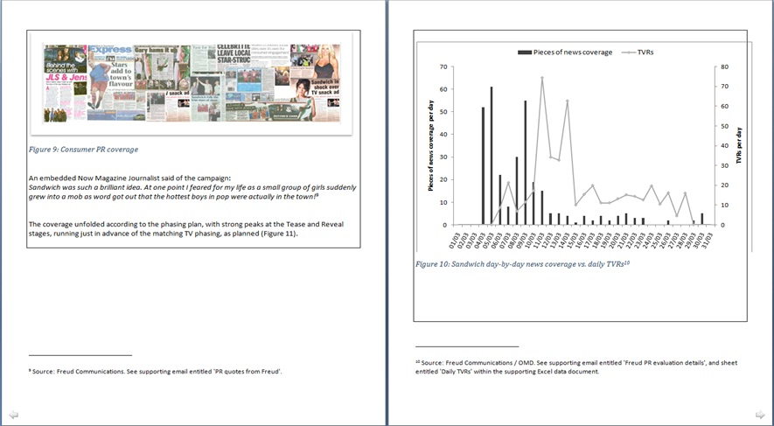
Claim
Provide hardcopy evidence, such as screengrabs. Do not simply supply a website link!

Evidence and Source Data itself as referenced by footnote.

Footnote directs to Evidence and Source Data itself

